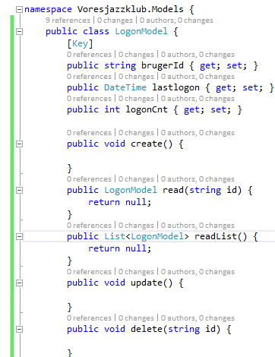

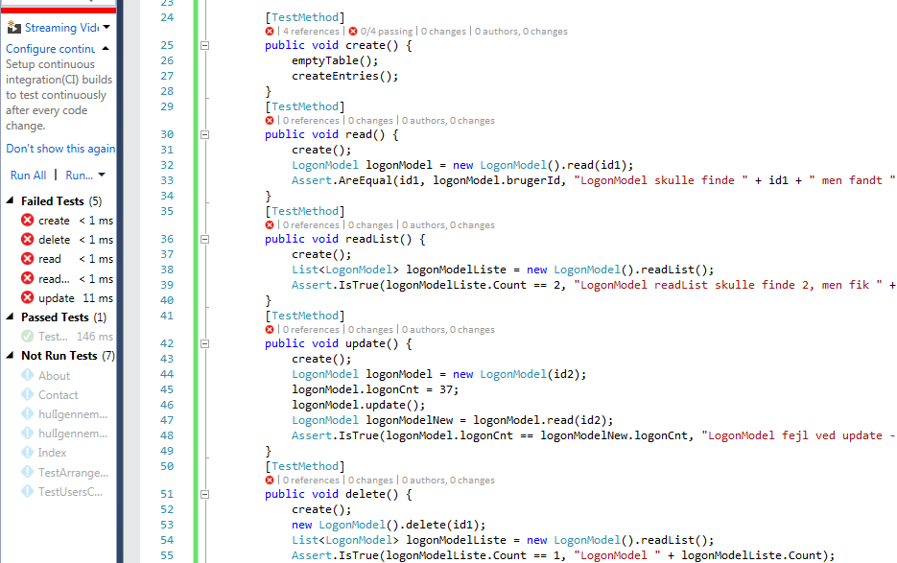

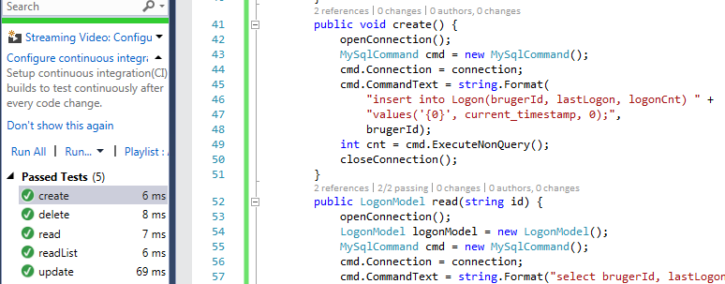



namespace Voresjazzklub {

public class RouteConfig {

public static void RegisterRoutes(RouteCollection routes) {

routes.IgnoreRoute("{resource}.axd/{\*pathInfo}");

routes.MapRoute(

name: "Default",

url: "{controller}/{action}/{id}/{id2}",

defaults: new { controller = "Home", action = "Index", id = UrlParameter.Optional, id2 = UrlParameter.Optional }

);

}

}